**Installation of Kubernetes Cluster on Master-Node**

#### Prepare Hostname, Firewall and SELinux

**#Setting Hostnames**

# hostnamectl set-hostname k8s-master

# hostnamectl set-hostname k8s-worker-1

# hostnamectl set-hostname k8s-worker-2

# cat <<EOF>> /etc/hosts

172.31.6.239 k8s-master

172.31.0.246 k8s-worker-1

172.31.0.247 k8s-worker-2

EOF

# modprobe br_netfilter

# echo '1' > /proc/sys/net/bridge/bridge-nf-call-iptables

# sed -i --follow-symlinks 's/SELINUX=enforcing/SELINUX=disabled/g' /etc/sysconfig/selinux

# reboot

#### Setup the Kubernetes Repo

cat <<EOF > /etc/yum.repos.d/kubernetes.repo

[kubernetes]

name=Kubernetes

baseurl=https://packages.cloud.google.com/yum/repos/kubernetes-el7-x86_64

enabled=1

gpgcheck=1

repo_gpgcheck=1

gpgkey=https://packages.cloud.google.com/yum/doc/yum-key.gpg https://packages.cloud.google.com/yum/doc/rpm-package-key.gpg

EOF

**Install Kubeadm and Docker**

yum install kubeadm docker -y

# systemctl enable kubelet

# systemctl start kubelet

# systemctl enable docker

# systemctl start docker

#### Initialize Kubernetes Master and Setup

# kubeadm init

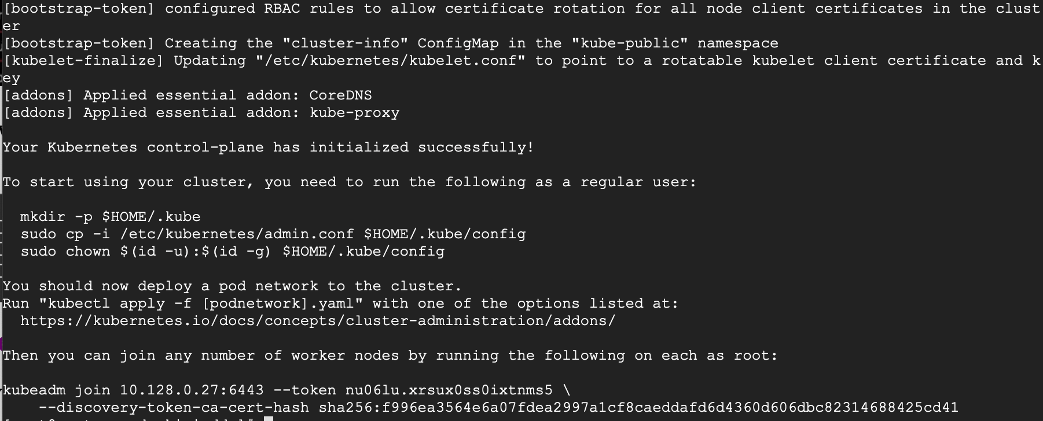

kubeadm join 172.31.11.196:6443 --token un5eox.exbev3zdzpho8wh6 \

--discovery-token-ca-cert-hash sha256:d80f977cd7dc43c5dfaaa0a163eec5b35c81baf975b575f5bd58830587000e35

mkdir -p $HOME/.kube

sudo cp -i /etc/kubernetes/admin.conf $HOME/.kube/config

sudo chown $(id -u):$(id -g) $HOME/.kube/config

#### Setup Your Pod Network

# export kubever=$(kubectl version | base64 | tr -d '\n')

# kubectl apply -f <https://cloud.weave.works/k8s/net?k8s-version=$kubever>

kadmin@k8s-master-~]$ kubectl get nodes

NAME STATUS ROLES AGE VERSION

k8s-master-1 Ready master 43m v1.18.6

### #Setting Up Worker Nodes to Join Kubernetes Cluster

#### Prepare Hostname, Firewall and SELinux

**#Setting Hostnames**

# hostnamectl set-hostname k8s-master

# hostnamectl set-hostname k8s-worker-1

# hostnamectl set-hostname k8s-worker-2

# cat <<EOF>> /etc/hosts

172.31.6.239 k8s-master

172.31.0.246 k8s-worker-1

172.31.0.247 k8s-worker-2

EOF

# modprobe br_netfilter

# echo '1' > /proc/sys/net/bridge/bridge-nf-call-iptables

# sed -i --follow-symlinks 's/SELINUX=enforcing/SELINUX=disabled/g' /etc/sysconfig/selinux

# reboot

#### Setup the Kubernetes Repo

cat <<EOF > /etc/yum.repos.d/kubernetes.repo

[kubernetes]

name=Kubernetes

baseurl=https://packages.cloud.google.com/yum/repos/kubernetes-el7-x86_64

enabled=1

gpgcheck=1

repo_gpgcheck=1

gpgkey=https://packages.cloud.google.com/yum/doc/yum-key.gpg https://packages.cloud.google.com/yum/doc/rpm-package-key.gpg

EOF

**Install Kubeadm and Docker**

yum install kubeadm docker -y

# systemctl enable kubelet

# systemctl start kubelet

# systemctl enable docker

# systemctl start docker

***Join the Worker Node to the Kubernetes Cluster***

# kubeadm join 10.128.0.27:6443 --token nu06lu.xrsux0ss0ixtnms5 --discovery-token-ca-cert-hash sha256:f996ea3564e6a07fdea2997a1cf8caeddafd6d4360d606dbc82314688425cd41

[kadmin@k8s-master1 ~]$ kubectl get nodes

NAME STATUS ROLES AGE VERSION

k8s-master Ready master 43m v1.18.6

k8s-worker-1 Ready <none> 6m11s v1.18.6

k8s-worker-2 Ready <none> 5m22s v1.18.6